Request Analyzer

# Overview

Request Analyzer fetches all the requests made by any user ever.

# Goal

It is prepared to ease out the process of analyzation of requests on daily basis. As we can filter them on various aspects and get it in a simple CSV format.

The parameters on which we can filter our data are:

* time Period- one can filter the requests lying in a particular date range.
* state Name - one can filter the requests lying in a particular state.
* business Group – one can get the requests of any particular organization.

# Solution /Logic design

For each request

Fetch request date, request org ,request state name

getRequests(host)

vcacCafeHost

If request org == given BG

OR “All”

If no

end

If no

end

If request state == given state

OR “All”

If (start date && end date != null)

If yes

Filter the requests lying in that interval only

Execute the action “validateRange”

Fetch request number,request name,request description,request output message,request completion date

If no

Array.push(request number,request,requested by,request date,request completion date,request state,description,request output message)

Write data to the file with the action “write dataToTheFile” and send the file with the mail through workflow “send mail”

end

# Requests properties

* Request Date – Date of the request
* Request – what is the request.
* Request Number
* Request Description – Request in detail
* Request output Message – message after complete processing of request.
* Request completion Date
* Request Approved Date

Dependencies

# Related Actions

* ValidateRange – It validates the requests lying between provided start date and end date.
* WriteDataToTheFile – It writes the requested data to the provided file.
* ValidateEmail – It validates the mail Address.
* regex – It formats the request description and request output message in csv file by eliminating commas with space.
* ValidateDate – it ensures that the start date should be less than the end date.
* BGdropdown – It provides the one with all the business group exists in AD as a predefined list of elements.

# Related Workflows

* Send Mail – It attaches the file with the mail and send it to the requester.

# Related Configuration elements

* fromName – Sender’s name who is sending the mail
* fromAddress – Sender’s email address
* VcacCafeHost – host through which VRO connect with VRA to fetch the required data.
* SmtpHost – with which one will be able to connect to the server to send the mail.
* CcAddress – it includes other member’s mail address to whom requester wants to send the mail.
* smtpPort - with which one will be able to connect to the server to send the mail.

# Attributes

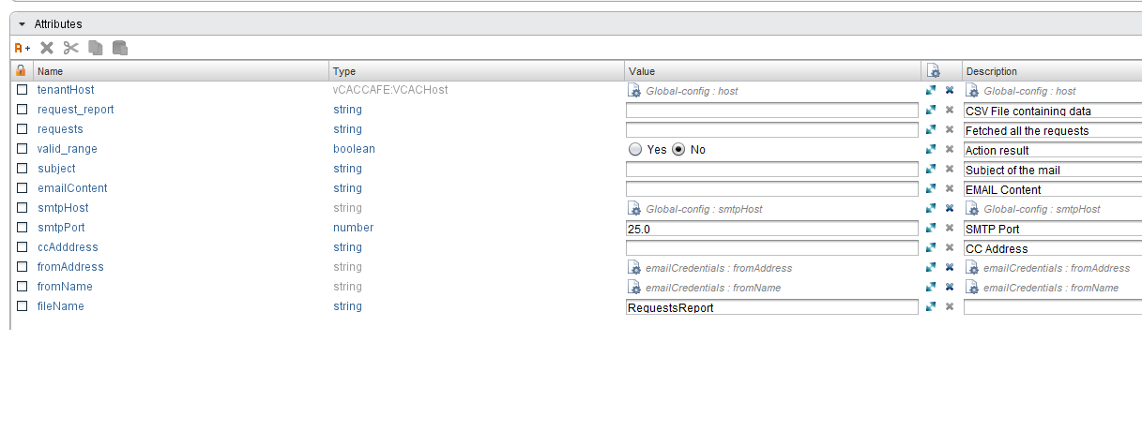

# Inputs

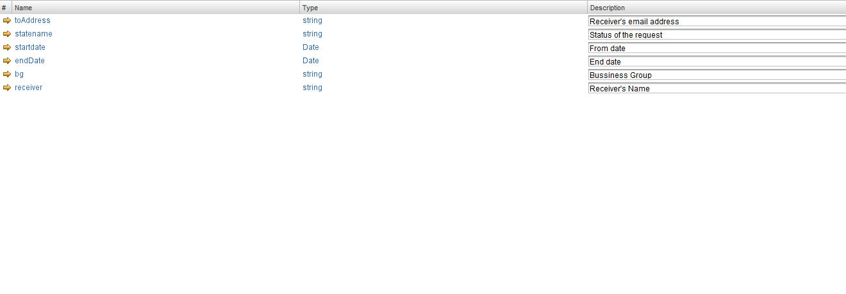

# Future scope

It can be extended to:

* fetch more properties of requests.
* fetch data related to one or more BG simultaneously.